**Submitting your PSY6306 Assignment**

1. Click the **Assignment submission** link in the grey area on the left hand side of the PSY6306 MOLE site

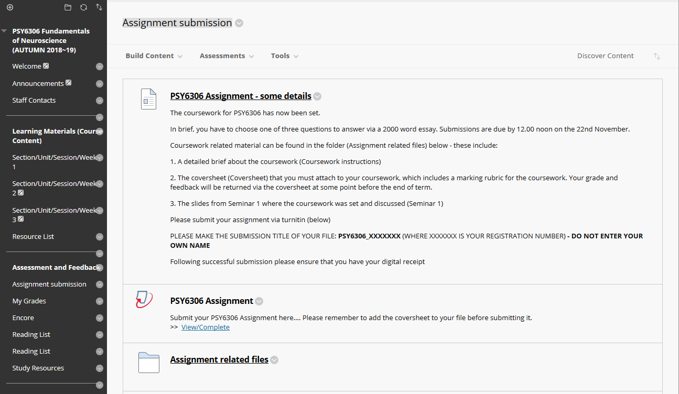

2. Click the **View/Complete** link under ‘PSY6306 Assignment’



3. Select your name (**Author**) from the pull down list, title your submission as instructed (PSY6306_ XXXXXXX) and **Choose the file you want to upload** and the Upload

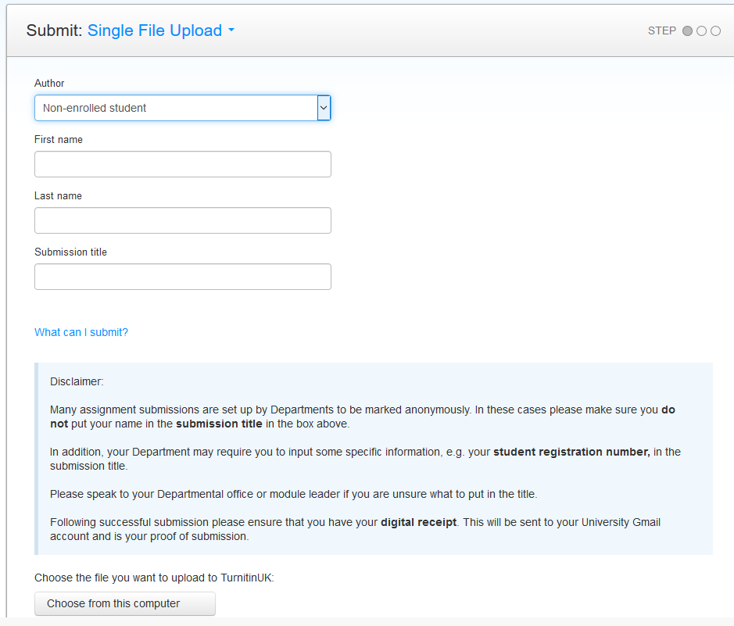

4. **Confirm** that you’re happy with the uploaded file

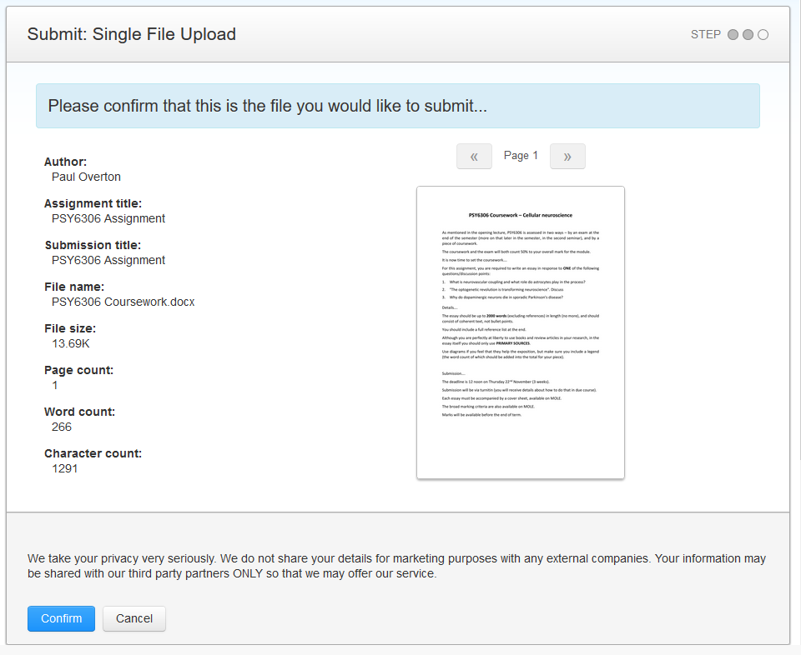

5. Print out a copy of your submission receipt

